

Atul Ghandhi

Exam Companion: A mobile application to support students in higher education during revision.

Computer Science

Final Year Undergraduate Project 2018/19

School of Electronic Engineering and Computer Science

Draft Report Submission: 18th March 2019

Supervisor: Dr Usman Naeem

# Table of Contents

Table of Contents 2

Abstract 4

Introduction 5

Background 5

Problem Statement 5

Aim 5

Objectives 5

Research Questions 5

Literature Review 6

Conventional revision techniques 6

Taking notes: 6

Practice questions: 6

Comprehensive revision techniques 7

Active learning: 7

Pomodoro technique: 8

Spaced repetition: 9

Gamification: 11

Student reflection 13

Application 14

Analysis and Design 14

Requirements Analysis 14

Functional 14

Non-functional 14

Design 14

UML 14

Wireframes - Interface 14

SDLC 14

Implementation 14

Rationale for the platform and technologies 14

What have you implemented and how? 14

External Libraries 14

Link to repository (bitbucket) 14

Results 14

Screenshot 14

Validation 14

Software Testing 14

Blackbox/Whitebox/Automated Unit Testing 14

Test Table 14

Framework 14

User Testing 14

Interface Testing 14

Usable 14

Fill Questionnaires or collect data from the App 14

Interface Evaluation benchmarks 14

Performance Testing 14

Memory Usage 14

Evaluation 15

Quantitative/Qualitative 15

How good your project was? 15

What was successful? 15

What was not successful? 15

Comparison to the gaps - ticking against the objectives/aim 15

Threats to validity 15

Limitations 15

Legal, Social, Ethical and Commercial Issues 15

Conclusions 15

Summary 15

Future work 15

Bibliography 16

Appendix 18

Project Plan 18

Gantt chart 18

Milestones 18

18

Personal Development Plan 18

Risk Analysis 19

# Abstract

Students in higher education spend much of their time revising course content to achieve better grades in their examinations. Not all revision techniques are equally effective, the techniques used by students can affect their learning, and in turn, their grades. The effectiveness of revision techniques used most frequently by students, as well as alternative revision methods used less often was analysed using relevant journal and conference papers. A software application was then produced, utilising the research by implementing features that will aid students in transitioning their revision techniques to more effective ones. The results found that spaced repetition and practice testing were the most effective revision techniques for test preparation. In addition, the Pomodoro technique was found to be an effective method of managing time during individual revision sessions.

The exam companion application includes features that are built upon research on the Pomodoro technique, spaced repetition and gamification.

# Introduction

## Background

University students studying for their Examinations rely heavily on passive studying methods such as highlighting or rereading large amounts of text to memorize required knowledge (Dunlosky, et al., 2013). Such methods, however, are ineffective at helping to understand complicated concepts or even to simply memorize information (Prince, 2004). Passive studying methods cause students to have a lower intrinsic motivation, lower conceptual learning scores and lower engagement in their courses (Carl A. Benware, 1984). Students using these methods could spend their time more productively using more effective studying techniques.

Furthermore, students can manage their time poorly by studying for long hours with few breaks in hopes of learning as much content as possible, known as ‘cramming’. This has been proven in multiple studies to be less effective than carefully managing how time is spent and allowing for breaks (Weng, et al., 2010). Methods of time management such as the Pomodoro technique can be used to complete more overall work in a given time frame by reducing the amount of time spent unfocused and distracted (Ruensuk, 2014).

## Problem Statement

Students revising for their examinations should spend their time in a way that maximises productivity to improve their academic performance and, in turn, their future prospects. Instead students in higher education often rely on ineffective revision techniques which undermine their achievements or do little to improve them.

## Aim

This project aims to aid students in changing their revision techniques to researched methods of studying proven to improve learning per unit time in the form of a software application. In doing so, the project aims to improve the grades achieved by university students in their examinations.

## Objectives

* To understand the studying and time management methods currently employed by university students by conducting interviews.
* To use academic papers from journals and conferences to discover the most effective revision and time management techniques that can help students to improve their revision sessions.
* To produce a software application that implements features that allow students to revise more effectively by improving their studying and time management techniques.

## Research Questions

* How can the revision methods of students be altered so that their productivity is maximised?
* How can time be managed by students when studying so that they achieve the maximum amount of learning/work for a given time frame?
* How can the Pomodoro technique utilised by students to improve time management within individual revision sessions?
* How can Spaced Repetition be utilised to aid students in memorising required course by managing time over their course leading up to exams?
* How can learning methods be modified to utilise Active learning, and how would this change the academic performance of a student.

# Literature Review

## Conventional revision techniques

### Taking notes:

Bretzing & Kulhavy (1979) investigated the effectiveness of four levels of note taking. 180 students were assigned one of five learning conditions and given a fictitious piece of text to study using their assigned technique in 30 minutes. The students were also limited to writing a maximum of three sentences of notes regardless of the technique being employed. A control group simply read the piece of text without taking any notes. The students were then tested on key facts from the text either immediately after studying it or one week later.

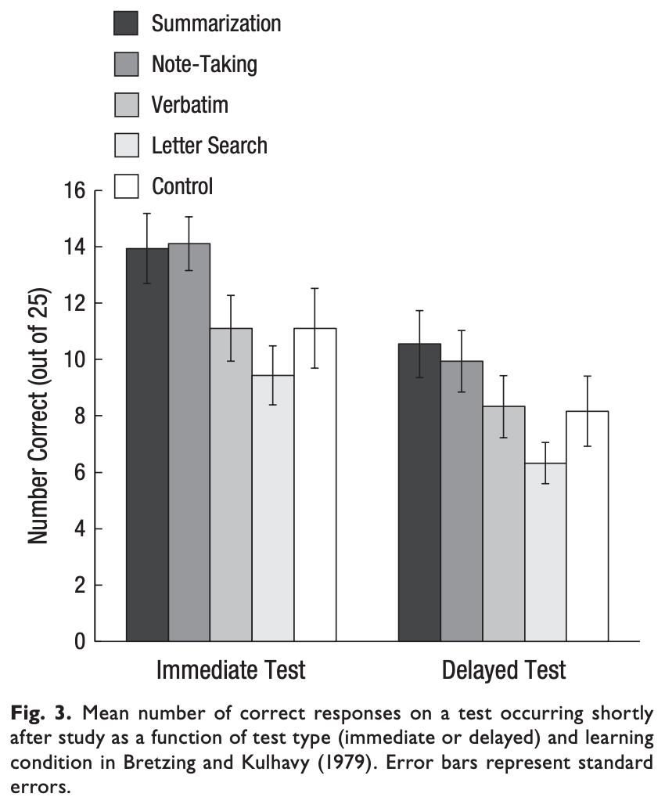

Figure 1: “Mean number of correct responses on a test occurring shortly after study as a function of test type (immediate or delayed) and learning condition in Bretzing & Kulhavy (1979). Error bars represent standard errors.” Dunlosky, et al. (2013)

The four levels of note taking were as follows:

1. Summarisation; condensing a larger amount of text into fewer words by excluding repetitive or unimportant information.

2. Paraphrasing (Note-Taking); rewriting key parts of the text such that it retains its meaning and volume but uses different words.

3. Verbatim copying; Copying the important parts of a text word for word.

4. Letter search; recording in notes all words that begin with capital letters.

Figure 1 shows the average number of correct responses out of 25 for each of the methods of note taking tested immediately after reviewing the information and with a delayed test.

Bretzing and Kulhavy’s results showed that with a delayed test scenario, most relevant to students in higher education, the students that summarised the text performed best, with those that paraphrased the text coming second. Students that copied the text word for word did as well as the control group that only read the text and students that used ‘letter search’ performed worse than had they not taken any notes at all.

The results suggest the active act of summarising or paraphrasing the information helped students perform better in their test than the passive acts of verbatim copying, reading or writing key words. The authors note “Additional time required for notetaking was only worthwhile when meaningful notes were taken” (Bretzing & Kulhavy, 1979), this ties in with Einstein, et al. (1985) which found the most successful students were those that recorded the greatest number of high importance propositions in their notes.

Similarly, Allison King (1992) found that students that summarised their lecture notes when reviewing them or used self-questioning strategies (Using question templates such as “how does x relate to y” to form and answer questions using their notes) outperformed those that simply reread/highlighted their notes.

The studies show that while taking notes is an effective method of revision, the techniques used when taking and reviewing notes can greatly influence the long-term retention of that information.

### Practice questions:

Practice testing was found to improve long term retention over 100 years ago (Abott, 1909) and in the hundred years since, hundreds of experiments have found it to enhance learning and retention (Dunlosky, et al., 2013).

Some studies, such as Runquist (1983), showed that testing improved retention as opposed to not testing. More recently, Pastötter & Karl-Heinz (2014) found “retrieval practice on previously studied information, compared to restudy of the same material, renders the information more likely to be remembered in the future”. This shows that using practice questions as a form of revision is more beneficial at retaining that information than traditional forms of studying, such as rereading or summarising notes. Likewise, Dunlosky, et al. (2013) compared 10 commonly used revision techniques, including rereading and summarising notes, and found practice testing to be the most effective revision technique.

Improving recall of previously studied material is known as the backward effect of testing. The forward effect of testing states “recall testing of previously studied information can enhance learning of subsequently presented new information” (Pastötter & Karl-Heinz, 2014).

Roediger and Karpicke (2006b) gave undergraduates a short text for initial study followed by either a second study session or by a practice test. One week later, recall was considerably better among the group that had taken the practice test than the group that had restudied (56% versus 42%).

Practice questions are clearly an excellent form of revision for students, as they consistently help with recall more than almost any other form of revision (Dunlosky, et al., 2013).

### 

Comprehensive revision techniques

There are countless ways to tweak revision techniques giving countless methods of revision. This project will therefore only look into revision methods that have been sufficiently studied, such that a clear conclusion can be drawn regarding their effectiveness. This will allow them to be better compared so that the software application that results from this research will incorporate features that most improve its users studying quality and thus grades.

### Active learning:

Learning in higher education today is generally done passively. Passive learning can be defined as being teacher focused, where the teacher presents information and the student sits and absorbs the presented information, without actually *doing* anything with it. On the other hand, active learning involves applying newly learned information immediately in some way. While there is no exact point where learning becomes active or passive, the more interaction with presented information and the more feedback on that interaction, the more active that method of learning is.

Passive learning includes revision methods most typically employed by students, such as rereading notes/textbooks and rewatching lectures; in these methods students try and absorb information without using it in any active way. There are many methods of active learning that involve doing something stimulating with the information to be learned. These include using the Feynman technique, where students describe a concept as simply as possible and relearn any part of the concept they cannot simplify. Creating flashcards or charts to represent the information in a different form or summarising notes as opposed to just rereading them are also active revision techniques.

Carl A. Benware (1984) investigated whether students that learned course content with an active orientation would perform better in class than those that learned with a passive orientation. This work notes that several studies (Cloward, 1967; Allen & Feldman, 1972) found that when students volunteered to tutor other students, the improvement in learning in the tutors was as great or greater than that of the students being tutored. It is further noted that other studies such as The National Commission on Resources for Youth (1972) and Goldschmid (1970) found the gains for teachers were more than just academic; tutoring also enhanced the perceived competence, motivation and self-esteem of the tutors. Benware hypothesised that these changes may be partly physiological due to the process of learning itself being different when learning to teach, in which case the improvements to the tutor should be present before any tutoring actually takes place. The work tests this hypothesis by having some students learn content (an article on brain functioning) with the expectation of teaching it to another student and by having other students learn the same content with the expectation of being tested on it, thus creating an active orientation (learning to teach) and a passive orientation (learning to be examined). The results of the study found that those students that learned to teach were more intrinsically motivated and perceived themselves to be more actively engaged with their environment than those students that learned to be examined. The students that learned to teach also perceived the ‘activity’ of learning to teach as much higher than learning to be examined, whereas those that learned only to be examined gave similar activity/passivity scores to both types of learning. Both groups of students were given an examination on the content and while the groups performed similar on rote learning questions, those that learned in order to teach performed significantly better on questions requiring conceptual understanding.

The above work covers the difference having an active orientation can make when revising examinable content, but it doesn’t show how any specific revision technique can be used by students to improve conceptual understanding or recall.

Dunlosky, et al. (2013) compared the effectiveness of several popular revision methods and found spaced practice (aka spaced repetition; analysed below) and practice testing to be the most effective studying techniques. The use of flash cards, an active learning method, can utilise both of those techniques. Creating flash cards requires content to be summarised to fit onto small cards which can then be reviewed multiple times conveniently to memorise the information on them. They can utilise practice testing by being double sided, with a prompt on one side and a piece of information that needs to be learned on the other. The student can then view the prompt on one side of the card and *test* how well they know the information on the other side of the card without seeing it.

Forbes, et al. (2013) investigated whether time would be more productively spent learning unknown flash cards alongside already learned cards or if students would be better off revising only unlearned cards. The study measured the learning rate (number of new cards learned per minute) of three students and found that interspersing additional known cards in flash card review sessions reduced learning rates compared to using only unlearned cards. Kupzyk, et al. (2011) found similar results, though it should be noted that both of these works involved very few participants (3 and 4 respectively) of a young age and the participants in Forbes, et al. (2013) all had learning disabilities.

### Pomodoro technique:

The Pomodoro technique is a time management method, originally created by Francesco Cirillo, that aims to help overcome distractions and procrastination when working. Using the Pomodoro technique, a person will work for a slot of 25 minutes on a given task during which they will only work on *that* task and ignore any other pending tasks or distractions. After the 25-minute slot, called a Pomodoro, the person will take a 5-minute break, followed by another 25-minute Pomodoro session. After every 4 consecutive Pomodoro’s, a larger 15-30-minute break is given to ‘refresh’ the mind.

The Pomodoro technique has several advantages. It allows the amount of time spent on a task to be easily quantified (by counting the number of Pomodoro's completed for a task) and it allows for larger tasks to be split into smaller chunks. The key aim of the time management method, however, is to improve productivity.

Ruensuk (2014) investigated the effectiveness of utilising the Pomodoro technique in an agile software development environment. This is relevant to students in higher education as both environments require focused work to meet strict deadlines.

This work measured the productivity of developers as time spent to complete a task, this was measured both before and after utilising the Pomodoro technique. The study also measured the number of internal and external interruptions that affected the developers, an internal interruption being something the developer was responsible for (i.e. checks Facebook) and an external interruption being something out of their control (i.e. boss or team member asks for help). Any Pomodoro that was interrupted was considered void and would begin again when the developer returned to work. The results collected over a two-month period (split into ‘sprints’ of two weeks each) found that the number of hours required to complete a similar task dropped by a third when using the Pomodoro technique over working with no time management.

Furthermore, as figure 2 illustrates, internal interruptions dropped dramatically, and external interruptions were also reduced. Internal interruptions may have dropped due to developers being more conscious of those interruptions and making an effort to stop them to prevent a Pomodoro slot being declared void. It is also likely that after using the Pomodoro technique for a while, developers were able to adapt the timeframe of the Pomodoro's and breaks to suit them; thus, reducing the number of distractions during their Pomodoro sessions. External interruptions likely dropped as a result of developers postponing dealing with interruptions until their Pomodoro slot was over whenever possible.

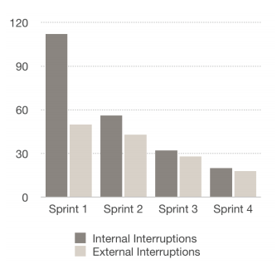

Figure 2: Mean number of internal and external interruptions during work. (Ruensuk, 2014)

The drawbacks of the technique, as mentioned by the developers after the two-month period, were that they had to wait for team members to finish their Pomodoro slots if they needed help and that external interruptions could not always be managed and would result in a void Pomodoro.

The study gives an insight into a practical implementation of the Pomodoro technique, its effectiveness and drawbacks. However, it was only conducted within a single company (Think Blue Data co. ltd) and with a small team of developers. As such the sample size may not be representative of all people that use the technique.

Weng, et al. (2010) also investigated the impact of the Pomodoro technique, or lack of it, with an agile distributed software development team based in Italy. The study found that using the Pomodoro technique enhanced the team’s productivity and helped with tracking the progress of a task and estimating the time required to complete it. The authors state the Pomodoro technique works because it is based on time-boxing; the idea of assigning a task an unchangeable time interval. When necessary, an unfinished task can be relegated to the next time interval. The time-box method works when it is ‘protected’, i.e. once begun its length does not change and distractions are deflected. As such, any definitive interruptions to a Pomodoro, internal or external, make it void. This improves focus and concentration on work by reducing distractions, time-wasting and anxiety linked to the passage of time. Moreover, Weng notes the Pomodoro technique allows “a sustainable working pace to be obtained through the alternation of work and rest and the combination of short breaks and longer pauses”.

The only issues found with the technique were that communication between team members was reduced as colleagues could not distract each other during a Pomodoro slot. This was solved with collective Pomodoro’s where the entire team used a single timer and took collective breaks. Another issue found was that some team members would use their break to discuss the task just completed in the Pomodoro, making the break as taxing as the Pomodoro slot and nullifying the core of Pomodoro time management. This was somewhat solved by incorporating team activities during the break sessions such as ‘5-minute fitness club’. Both of these issues would not be relevant to the average student independently studying for exams, the benefits of increased productivity with time management, however, would be relevant to them.

The above studies show that the Pomodoro technique is an effective and easy to implement method of improving productivity during intensive work.

### Spaced repetition:

Our brains memorise information more firmly with more repetitions of that information and each time a piece of information is repeated it takes longer for our brains to forget it. Repeated reviews of information can take place in a ‘massed’ heap (where information is reviewed multiple times consecutively) or reviews can be spaced over time. 254 studies involving 14,811 participants found spaced practice was far more effective for recall than massed practice for all retention intervals (Cepeda, et al., 2006).



Table 1: retention of informationt when tested; for massed and spaced practice among participants of various studies.

There is little consensus to account for the retrieval advantages of spaced practice though several theories exist. A popular one, backed by empirical evidence, is the study-phase retrieval theory (Braun & Rubin, 1998; Thios & D’Agostino, 1976) which states that a restudy of information prompts a retrieval of the memory trace of the first presentation. This causes an elaboration on the first memory trace enhancing long term recall. Massed practice does not yield the same results as the first memory trace is active during the restudy of information, so the information is not retrieved.

The above studies show that spaced repetition is an effective method of improving recall and students trying to memorise information should therefore space out their review of each concept over time instead of massing the practice of each concept in one go. Students are often constrained for time and as such, spaced repetition will be most beneficial to them when restudy of information has to occur as infrequently as possible while the information recall is still relatively high.

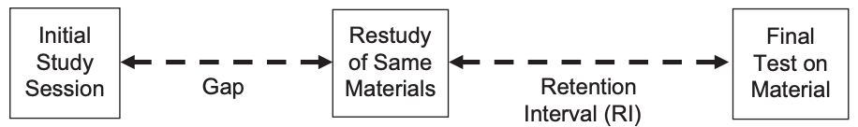

Figure 3 Structure of most studies investigating the impact of the spacing effect on learning

Lag

Cepeda et al. (2008) tested 10 different spacing intervals (called lags) between initial practice and review of trivia facts; ranging from 0 to 150 days. A final test was administered between 7 and 350 days after the final review session; this period is known as the retention interval. The experiment found that retention of the facts was highest when the ‘lag’ was between 10 to 20% of the retention interval. Since students are often limited in time, we can take the upper bound of 20%. Therefore, according to this study, a student revising for something on the first day of term knowing they will be tested on that content in an exam in 9 months (270 days) should review that information every 54 days (20% of 270) for it to remain memorised.

Unfortunately, the above strategy assumes all the content a student needs to learn will be first reviewed on their first day, which is not the case. For spaced repetition to have maximum efficiency in an educational environment, review scheduling must balance the competing priorities of introducing new information and reviewing old information such that the rate of learning is maximised.

Reddy et al. (2016) discusses the *Leitner System* as a solution to solve review scheduling. The system relies on two sided flashcards, with a prompt on one side (i.e. key word) and information that needs to be learned on the other (i.e. definition of key word). The cards are arranged in a series of decks where new information is added to ‘deck 1’ and the cards in each deck are reviewed in a ‘First-In-First-Out’ queue with the first deck having the highest priority and each following deck having a lower priority. Each time a card is reviewed, if the prompt is answered correctly (i.e. the person correctly recalls the definition of the key word) the card is moved a single step down to a lower priority deck and if the prompt is answered incorrectly then the card is moved one step up to a higher priority deck. Cards incorrectly recalled in deck 1 stay in deck 1 and cards correctly recalled in the final deck are removed from the system. Essentially, this forms an ordered list of flash cards to be learned such that cards will be repeatedly reviewed until memorised.

Figure 4 gives an illustration of how the Leitner system can be implemented. New information is added to deck 1 to be memorised. Red lines show transition of cards to higher priority decks and green lines show transition of cards to lower priority decks. Cards in deck 1 are reviewed every learning session, cards after deck 5 are ‘retired’ and no longer need to be reviewed. Cards in decks 2, 3, 4 and 5 are reviewed every 2nd, 3rd, 4th and 5th learning session respectively. The interval between the learning sessions would be up to each individual user; though they would typically be several days apart to utilise the benefits of spaced repetition.

Figure 4: a graphical representation of the Leitner system (Reddy, et al., 2016)

The above research studies all agree that spacing out information reviewal over time leads to superior recall in a test environment than ‘massed revision’.

### Gamification:

Gamification is the concept of applying typical gaming elements, such as gaming mechanics, aesthetics and game thinking, to non-gaming activities such as education (Borges, et al., 2014). Digital games are capable to motivating the user to keep playing, holding their interest and convincing them to solve internal conflicts and problems within the game. In theory, gamifying revision would increase student motivation to study and help reduce boredom induced procrastination. The majority of studies on gamification as applied to education concern higher education as the benefits of gamification have sparked a recent growing interest in developing eLearning environments equipped with gamified elements (Borges, et al., 2014). O’Donovan, et al. (2013) claims higher education is already much like a game where “students start as novices (freshmen). As they progress, they go on quests (lectures) to learn skills (coursework) and are then tested on these through challenges (tests and assignments) that determine whether they qualify for the final boss-battle (exams) in order to level up (pass the year) or lose the game (failure).”

Butler & Ahmed (2016) gamified an introductory Computer Science course which they found new students were likely to struggle with. The game used a ‘space-ship’ like interface to teach students concepts such as stacks and selection sort. The work assessed the effectiveness of gamification used surveys and discussions with the students. The results show the majority of students claimed they learned better with an active learning style and agreed that learning difficult concepts through a gamified environment helped with understanding them. A large number of students said they lost the motivation to learn concepts that were too difficult to understand. The study found that using games to learn increased motivation, retention and conceptual understanding of concepts in students. While this work showcases an example of how gamification can be utilised in an educational environment and presents student opinions of gamifying learning, little quantitative analysis is provided.

Nah, et al. (2014) carried out review of papers relating to gamification in educational and learning contexts. The reviews included Brewer, et al. (2013), which found gamification in the form of points and prizes for tasks completed increased the motivation of students (aged 5 - 7) and task completion rose from 73% to 97%. Gibson, et al. (2015) explained that using digital badges alongside points and leader boards would “motivate some learners to continuously engage with online materials and activities”. Goehle (2013) integrated levels and achievements in an online calculus course. The work found higher engagement levels from students on the course, with half the students completing more homework than required for additional achievements. In an optional survey the majority of students said they felt the system was rewarding and appreciated the extra acknowledgement for doing their homework.

O’Donovan, et al. (2013) gamified a games development course. Students were given experience points for lecture attendance, performance on quizzes, participation in class exercises and other activities. Gaining experience points also led to gaining in game currency, which could be used to do things like buying assignment extensions to give the gamification real life impact. Several other gamification elements were also implemented including progress bars, leader boards and badges. In a questionnaire, students felt gamification improved their understanding of and engagement with the course. The results found leader boards to be the most effective at motivating students to engage with the course. They also found a significant increase in lecture attendance, much higher than other computer science courses in the same department and most importantly the results found a statistically significant improvement in student grades from the previous year. It should be noted that gamifying a games development course may have skewed the results as the participants would likely be avid gamers already and more likely to engage in a gamified course than the average student.

While the above papers show gamification to be a promising method of improving the learning experience of students, not all studies have found it to be effective. Barata, et al. (2015) gamified a computer science course in Information Systems with multiple game design elements such as points, levels, leader boards, challenges, and badges. The results indicate gamification of the course led to higher student engagement and participation as well as an increased attendance in lectures implying increased interest or enjoyment in the course. However, this did not lead to a significant improvement in student grades.

Berkling & Thomas, (2013) also gamified a computer science course in Software Engineering including game-based elements such as achievements, points, progress and leader boards. Questionnaires administered to the students revealed that a majority of them did not consider themselves to be *gamers* and many of them found gamification of the online platform a hindrance to their learning rather than an asset. The overall feedback received from students showed no consensus with positive and negative views being balanced. Features such as points and public recognition for helping others through a forum were functional but not utilised by students. The work suggests that this was partly due to students finding the transition between teaching styles unnecessary additional work and partly due to a strong culture of formal, traditional schooling. The work found that explicitly naming the platform “gamified” discouraged some students that were opposed to the idea of learning through games and suggested that changing the learning environment to something more active would need to be implemented slowly to be accepted.

The above studies demonstrate that while gamification can help motivate and engage students in their work, overhauling a system to make it completely gamified can adversely affect student engagement with the course. Gamification appears to be most effective if it is not explicitly named as such and is subtly embedded into a system rather than being the focus point.

## Student reflection

Interviews were conducted with 24 students, from multiple universities, to investigate current approaches to exam revision and time management.

Students were asked about their approaches to revision when distant from examinations and during exam season. When distant from examinations, 91.6% of the students mentioned in some form “reading or writing notes using lecture slides and/or recordings”; with ~25% of those students only reading the notes provided. In follow up question’s students said they copied or reworded lecture slides with the intention of rereading them when examinations approached. Very few students used their notes in an active manner; such as summarising their notes or using them to create charts or revision cards.

Revision techniques used by students changed when exams approached, with approximately 71% of students switching partly or entirely to completing practice exam questions, with 29% spending the run up to exams taking and/or reading more notes on course content. Students also claimed they spent significantly more time revising as exams approached, taking fewer breaks and leisure time off revision.

Since practice exam questions are one of the most effective revision techniques (Dunlosky, et al., 2013), this means the majority of students spend most of the year revising with less effective revision methods and switch to more effective ones leading up to exams.

The students were then asked how they timed individual revision sessions and how they scheduled revision across their timetable. The majority of students (66.7%) said they did not time revision sessions except when completing past papers in a set amount of time. For other forms of study such as taking or reading notes revision was generally done until students got distracted, tired or had a timetabled activity to attend. The remaining third of students mentioned timing revision sessions by assigning a block of time to each module or subject for the day to make sure all subjects were covered.

Regarding scheduling revision sessions, a quarter of the students said they did not schedule revision sessions beforehand, instead working on whichever task seemed most pressing at the time. Of the students that used a timetable to schedule their revision sessions, the scheduling used was largely centred around ensuring each subject had an equal amount of time dedicated to it and largely came into effect during exam season when lectures stopped. During semester most students worked on whichever module they felt most needed their attention, either due to a lack of understanding or a deadline approaching for an assessed task.

The interview responses show time management is not to a concern for many students as they are unaware of its immense potential to improve their productivity when studying. Utilising the Pomodoro technique and spaced repetition would be hugely beneficial to students that do not time their revision at all.

Once exam season approached, over 70% of students used a digital timetable on their smart phones with a calendar or timetable application. A small number (~4%) used a written timetable to schedule their events. Of the students using a timetable, 80% dedicated each day to a different module or examination and the remainder split each day into several slots for different modules. Here again, the majority of students said they revised subject knowledge in blocks (one lesson a day) instead of splitting up practice over several days which would utilise spaced repetition and greatly improve their recall of the revised content. Students do not have to spend more time studying to improve recall, they simply need to schedule the time they already spend differently.

## Application

# Analysis and Design

## Requirements Analysis

### Functional

### Non-functional

## Design

### UML

#### Class Diagrams

#### ERD

#### Use cases

### Wireframes - Interface

## SDLC

# Implementation

## Rationale for the platform and technologies

## What have you implemented and how?

## External Libraries

## Link to repository (bitbucket)

# Results

## Screenshot

# Validation

## Software Testing

### Blackbox/Whitebox/Automated Unit Testing

### Test Table

### Framework

## User Testing

### Interface Testing

### Usable

### Fill Questionnaires or collect data from the App

## Interface Evaluation benchmarks

## Performance Testing

### Memory Usage

# Evaluation

## Quantitative/Qualitative

### How good your project was?

### What was successful?

### What was not successful?

## Comparison to the gaps - ticking against the objectives/aim

## Threats to validity

## Limitations

# Legal, Social, Ethical and Commercial Issues

# Conclusions

## Summary

## Future work

# Bibliography

Abott, E. E., 1909. On the analysis of the factor of recall in the learning process.. *The Psychological Review: Monograph Supplements,* 11(1), pp. 159-177.

Allen, V. L. & Feldman, R. S., 1972. *Learning Through Tutoring: Low-Achieving Childern as Tutors.,* Wisconsin Univ., Madison: Wisconsin Research and Development Center for Cognitive Learning.

Barata, G., Gama, S., Jorge, J. & Gonçalves, D., 2015. Gamification for smarter learning: tales from the trenches. *Smart Learning Environments,* 2(10).

Berkling, K. & Thomas, C., 2013. *Gamification of a Software Engineering course and a detailed analysis of the factors that lead to it's failure.* s.l., 2013 International Conference on Interactive Collaborative Learning, ICL 2013.

Borges, S. d. S., Reis, H. M., Durelli , V. H. S. & Isotani, S., 2014. *A Systematic Mapping on Gamification Applied to Education.* s.l., Proceedings of the ACM Symposium on Applied Computing..

Braun, K. E. & Rubin, D. C., 1998. The spacing effect depends on an encoding deficit, retrieval, and time in working memory: evidence from once-presented words.. *Memory,* , 6(1), pp. 37-66.

Bretzing, B. H. & Kulhavy, R. W., 1979. Notetaking and depth of processing. *Contemporary Educational Psychology,* 4(2), pp. 145-153.

Brewer, R. et al., 2013. *Using Gamification to Motivate Children to Complete Empirical Studies in Lab Environments.* s.l., 12th International Conference on Interaction Design and Children.

Butler, S. & Ahmed, D. T., 2016. *Gamification to Engage and Motivate Students to Achieve Computer Science Learning Goals.* Charlotte, North Carolina, Conference Publishing Services: 2016 International Conference on Computer Science and Computational Intelligence.

Carl A. Benware, E. L. D., 1984. Quality of Learning With an Active Versus Passive Motivational Set. *American Educational Research Journal,* 21(4), pp. 755-765.

Cepeda, N. J. et al., 2006. Distributed practice in verbal recall tasks: A review and quantitative synthesis. *Psychological Bulletin,* , 132(3), pp. 354-380.

Cepeda, N. J. et al., 2008. *Spacing effects in learning: A temporal ridgeline of optimal retention - eScholarship.* [Online]   
Available at: http://escholarship.org/uc/item/0kp5q19x  
[Accessed 15 2 2019].

Cloward, R. D., 1967. Studies in Tutoring. *THE JOURNAL OF EXPERIMENTAL EDUCATION,* 3(1), pp. 14-25.

Dunlosky, J. et al., 2013. Improving Students' Learning With Effective Leaning Techniques: Promising Directions From Cognitive and Educational Physology. *Psychological science in the public interest,* 14(1), pp. 4-58.

Einstein, G. O., Morris, J. & Smith, S., 1985. Note-taking, individual differences, and memory for lecture information.. *Journal of Educational Psychology,* 77(5), pp. 522-532.

Forbes, B. E., Skinner, C. H., Black, M. P. & Yaw, J., 2013. Learning Rates and Known-To-Unknown Flash-Card Ratios: Comparing Effectiveness While Holding Instructional Time Constant. *Journal of Applied Behavioural Analysis,* 46(4), pp. 832-837.

Gibson, D. et al., 2015. Digital badges in education. *Education and Information Technologies,* 20(2), pp. 403-410.

Goehle, G., 2013. Gamification and Web-based Homework. *PRIMUS,* 23(3), pp. 234-246.

Hartwig, M. & Dunlosky, J., 2012. Study strategies of college students: Are self-testing and scheduling related to achievement?. *Psychon Bull Rev,* Volume 19, pp. 126-134.

Kang, S. H. K., 2016. Spaced Repetition Promotes Efficient and Effective Learning: Policy Implications for Instruction. *Policy insights from the behavioral and brain sciences,* , 3(1), pp. 12-19.

King, A., 1992. Comparison of Self-Questioning, Summarizing, and Notetaking-Review as Strategies for Learning From Lectures. *American Educational Research Journal,* 29(2), pp. 303-323.

Kupzyk, S., Daly, E. J. & Andersen, M. N., 2011. A COMPARISON OF TWO FLASH-CARD METHODS FOR IMPROVING SIGHT-WORD READING. *Journal of Applied Behavioural Analysis,* 44(4), pp. 781-792.

Macan, T. H., Shahani, C., Dipboye, R. L. & Phillips, A. P., 1990. College Students' Time Management: Correlations With Academic Performance and Stress. *Journal of Educational Psychology,* 82(4), pp. 760-768.

Nah, F. F.-H. et al., 2014. *Gamification of Education: A Review of Literature.* Cham, Springer International Publishing.

O’Donovan, S., Gain, J. & Marais, P., 2013. *A Case Study in the Gamification of a University-level Games Development Course.* s.l., s.n., pp. 242-251.

P. Ramsden, N. J. E., 1981. EFFECTS OF ACADEMIC DEPARTMENTS ON STUDENTS’ APPROACHES TO STUDYING. *British Journal of Educational Psychology,* Volume 51, pp. 368-383.

Pastötter, B. & Karl-Heinz, B. T., 2014. Retrieval practice enhances new learning: the forward effect of testing. *Frontiers in psychology doi:10.3389/fpsyg.2014.00286,* 5(286), pp. 1-5.

Prince, M., 2004. Does Active Learning Work? A Review of the Research. *Journal of Engineering Education,* 93(3), pp. 223-231.

Reddy, S., Labutov, I., Banerjee, S. & Joachims, T., 2016. *Unbounded Human Learning: Optimal Scheduling for Spaced Repetition.* San Francisco, Conference on Knowledge Discovery and Data Mining.

Ruensuk, M., 2014. *An Implementation to Reduce Internal/External Interruptions in Agile Software Development Using Pomodoro Technique,* Bangkok: Stamford Imternational University.

Runquist, W. N., 1983. Some effects of remembering on forgetting. *Memory & Cognition,* 11(6), pp. 641-650.

Thios, S. J. & D'Agostino, P. R., 1976. Effects of repetition as a function of study-phase retrieval. *Journal of Verbal Learning and Verbal Behavior,* , 15(5), pp. 529-536.

Weng, X., Gobbo, F. & Lane, M., 2010. Turning Time from Enemy into an Ally Using the Pomodoro Technique. In: P. Agerfalk, D. Smite & N. B. Moe, eds. *Agility Across Time and Space.* Limerick: Springer-Verlag, pp. 149-166.

Zirguezi, 2012. *A graphical description of the Leitner system..* [Art].

# Appendix

## Project Plan

### Gantt chart

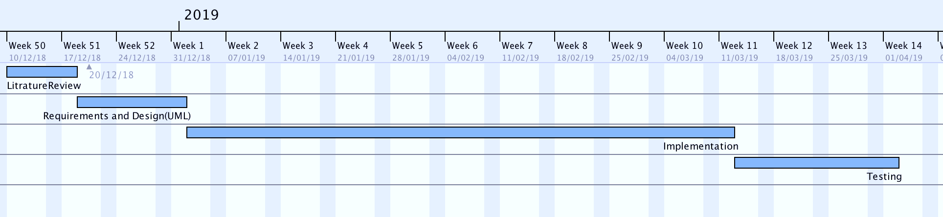

### 

### Milestones

## 

## Personal Development Plan

# Risk Analysis

|  |  |  |  |  |
| --- | --- | --- | --- | --- |
| Description of risk | Description of impact | Likelihood rating | Impact rating | Preventative actions |
| Illness or accident | Could case project deadlines to be missed and cause delays in completion of project resulting in an unfinished final product. | Low | High | Risk can be reduced by taking greater precautions to ensure personal health and safety. This would include promptly checking up any medical issues with a doctor to prevent a long-term illness that would impact progress on the project, as well as avoiding unnecessary risks such as jogging at night when visibility for cars is low and accidents can happen. |
| Poor time management | Missing deadlines and managing time poorly could result in an unfinished project, lacking in basic features and poorly analysed and tested with software bugs and errors. | Medium | High | Project progress will be reviewed on a weekly basis and noted down in a log along with any issues that set back the project – so that in the following week those issues can be addressed.  Project progress will also be compared to the time plan on a weekly basis, and where the project diverts from the time plan, it will be remodelled to fit in all required work by the deadlines set. |
| Failure to acquire participants for surveys/interviews | Could cause an inability to conduct important research for the project resulting in a final product that is unfit for its target demographic. | Low | High | The methods used to attract participants for surveys and interviews will be diversified.  - Several online websites and social media platforms will be used to advertise surveys to gain a large sample size for research conducted.  - Participants for interviews will be gained through advertising to peers at Queen Mary’s as well as by contacted students from other institutions through social media to participate in the study.  - If the above two methods still do not attract the required number of participants for research, financial incentive could be provided though websites such as Google Surveys. |
| Failure to acquire required information | If suitable research articles and journals do not exist or cannot be accessed, there could be a lack of research available relevant to the project. This could make the final product unable to fulfil the projects objectives. | Low | High | Multiple online sources will be used to search for and find relevant research materials.  In addition, research sections of public and academic library’s will be used so that a suitable number of relevant studies can be used in the product research. |
| Inadequate testing | Poor testing methods and analysis could lead to bugs and errors in the final application passing through the testing phase without being fixed. | Medium | Medium – High (depending on bug) | The completed application will be debugged and tested by the developer and other testing participants using black-box and white-box testing methods to ensure thorough testing. |